Fidelity Check – School Induction Programme (SIP)
Please do not hesitate to contact SFET Teaching School Hub if you have any questions regarding this form, your ECF/induction options or for clarity regarding school roles and responsibilities.
School Name:
School URN:
Headteacher:

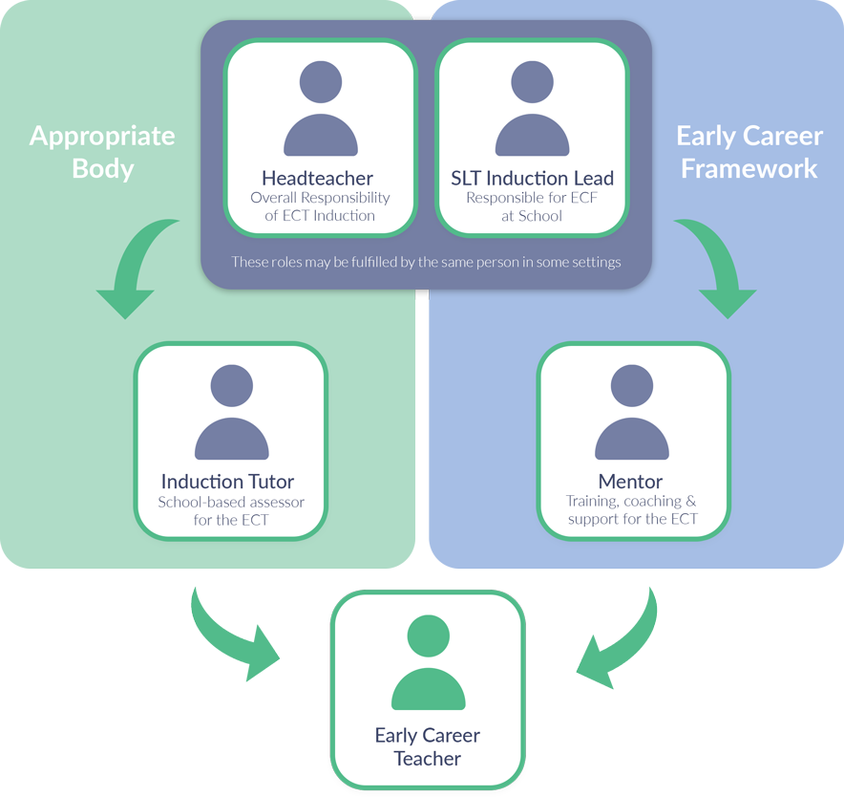

Fidelity Check – School-Based Induction Programme (SIP)

Each school offering and delivering their own Early Career Framework (ECF) school-based induction programme (SIP) is subject to a series of fidelity checks by an appropriate body. This form is to be used by schools to evidence to their Appropriate Body how they have used the Early Career Framework to design and deliver training and mentor sessions. Guidance on using this form can be found in chapter 4 of the Appropriate Bodies Guidance: Induction and the Early Career Framework.

This form should not be used to describe in detail every session delivered over the entire induction period but should give the appropriate body a clear understanding of how the ECT(s) will receive training and mentoring to support every statement of the ECF in sufficient depth and breadth, and with robust evidence-based rationales for how the framework has been translated into an ECF-based training programme.
Staff planning induction are expected to reference the ‘learn that’ and ‘learn how to’ statements from the Early Career Framework which can be found online: Early Career Framework (publishing.service.gov.uk).

Fidelity Check Stage One

- The member of staff responsible for planning the two-year ECF induction should complete this form
- This form should be signed off by the headteacher prior to the start of induction and sent to the appropriate body for verification (fidelity to the ECF)

Fidelity Check Stage Two

- The appropriate body will check implementation of the school’s plans prior to the completion of year one

Fidelity Check Stage Three

- The appropriate body will check actual delivery of the planned ECF-based induction prior to the final assessment point

School-Based Induction Programme (SIP) – School Plans

Part A – Overview: scheduling/sequencing

1. Give a termly overview of how the induction programme has been scheduled and sequenced across the full 2-year induction period. This should cover the topics that you plan to cover each term and in what order. It should give an explanation and rationale for why specific topics will be covered in this order and how this learning will be consolidated in later terms.

[Suggested word count: 1,000. Continue on a separate sheet if necessary]

2. At the review points agreed with the appropriate body, outline where delivery has diverged from the planned sequence. Explain what mitigations are in place, including dates where appropriate.

Part B – Delivery plans

- High Expectations (Standard 1 – Set high expectations)

A: With reference to the relevant ‘learn that’ and ‘learn how to’ statements, explain how this statement will be delivered.
Explanation, and robust rationale, should cover:
- Intended mode(s) of delivery (for example group training, virtual learning 1:1) and balance between contact time and self-directed study
- How mentoring will support ECT’s learning of this statement

B. At the review points agreed with the appropriate body, outline where delivery has diverged from the planned sequence. Explain what mitigations are in place, including dates where appropriate.

[To be completed prior to review points (prior to the end of year one and prior to final assessment]

- How Pupils Learn (Standard 2 – Promote good progress)

A: With reference to the relevant ‘learn that’ and ‘learn how to’ statements, explain how this statement will be delivered.
Explanation, and robust rationale, should cover:
- Intended mode(s) of delivery (for example group training, virtual learning 1:1) and balance between contact time and self-directed study
- How mentoring will support ECT’s learning of this statement

B. At the review points agreed with the appropriate body, outline where delivery has diverged from the planned sequence. Explain what mitigations are in place, including dates where appropriate.

[To be completed prior to review points (prior to the end of year one and prior to final assessment]

- Subject and Curriculum (Standard 3 – Demonstrate good subject and curriculum knowledge)

A: With reference to the relevant ‘learn that’ and ‘learn how to’ statements, explain how this statement will be delivered.
Explanation, and robust rationale, should cover:
- Intended mode(s) of delivery (for example group training, virtual learning 1:1) and balance between contact time and self-directed study
- How mentoring will support ECT’s learning of this statement

B. At the review points agreed with the appropriate body, outline where delivery has diverged from the planned sequence. Explain what mitigations are in place, including dates where appropriate.

[To be completed prior to review points (prior to the end of year one and prior to final assessment]

- Classroom Practice (Standard 4 – Plan and teach well structured lessons)

A: With reference to the relevant ‘learn that’ and ‘learn how to’ statements, explain how this statement will be delivered.
Explanation, and robust rationale, should cover:
- Intended mode(s) of delivery (for example group training, virtual learning 1:1) and balance between contact time and self-directed study
- How mentoring will support ECT’s learning of this statement

B. At the review points agreed with the appropriate body, outline where delivery has diverged from the planned sequence. Explain what mitigations are in place, including dates where appropriate.

[To be completed prior to review points (prior to the end of year one and prior to final assessment]

- Adaptive Teaching (Standard 5 – Adapt Teaching)

A: With reference to the relevant ‘learn that’ and ‘learn how to’ statements, explain how this statement will be delivered.
Explanation, and robust rationale, should cover:
- Intended mode(s) of delivery (for example group training, virtual learning 1:1) and balance between contact time and self-directed study
- How mentoring will support ECT’s learning of this statement

B. At the review points agreed with the appropriate body, outline where delivery has diverged from the planned sequence. Explain what mitigations are in place, including dates where appropriate.

[To be completed prior to review points (prior to the end of year one and prior to final assessment]

- Assessment (Standard 6 – Make accurate and productive use of assessment)

A: With reference to the relevant ‘learn that’ and ‘learn how to’ statements, explain how this statement will be delivered.
Explanation, and robust rationale, should cover:
- Intended mode(s) of delivery (for example group training, virtual learning 1:1) and balance between contact time and self-directed study
- How mentoring will support ECT’s learning of this statement

B. At the review points agreed with the appropriate body, outline where delivery has diverged from the planned sequence. Explain what mitigations are in place, including dates where appropriate.

[To be completed prior to review points (prior to the end of year one and prior to final assessment]

- Managing Behaviour (Standard 7 – Managing behaviour effectively)

A: With reference to the relevant ‘learn that’ and ‘learn how to’ statements, explain how this statement will be delivered.
Explanation, and robust rationale, should cover:
- Intended mode(s) of delivery (for example group training, virtual learning 1:1) and balance between contact time and self-directed study
- How mentoring will support ECT’s learning of this statement

B. At the review points agreed with the appropriate body, outline where delivery has diverged from the planned sequence. Explain what mitigations are in place, including dates where appropriate.

[To be completed prior to review points (prior to the end of year one and prior to final assessment]

- Professional Behaviours (Standard 8 – Fulfil wider professional responsibilities)

A: With reference to the relevant ‘learn that’ and ‘learn how to’ statements, explain how this statement will be delivered.
Explanation, and robust rationale, should cover:
- Intended mode(s) of delivery (for example group training, virtual learning 1:1) and balance between contact time and self-directed study
- How mentoring will support ECT’s learning of this statement

B. At the review points agreed with the appropriate body, outline where delivery has diverged from the planned sequence. Explain what mitigations are in place, including dates where appropriate.

[To be completed prior to review points (prior to the end of year one and prior to final assessment]

Part C – Additional planning documents
Schools may have separate school-designed induction plans and schedules. On completion of this form, you may attach any additional plans/schedules to be reviewed by the appropriate body.
If you have attached additional documents please list them here with a very short summary of what each document contains/demonstrates.

Part D – Signature
By signing on this page, I confirm that the information provided on this form, to the best of my knowledge, is accurate, correct and complete.
Headteacher Signature

Date (DD/MM/YYYY)

GDPR statement on data collection: As documented in Statutory Guidance, ABs are responsible for the collection, retention and storage of data. ABs are responsible for submitting relevant data to the TRA via the DQT. Please visit www.tshubsfet.org.uk to read privacy notice.

Please return completed form to Gabby Janes (gjanes@sfet.org.uk)

