Fidelity Check – Core Induction Programme (CIP)

Please do not hesitate to contact SFET Teaching School Hub if you have any questions regarding this form, your ECF/induction options or for clarity regarding school roles and responsibilities.
School Name:
School URN:
Headteacher:

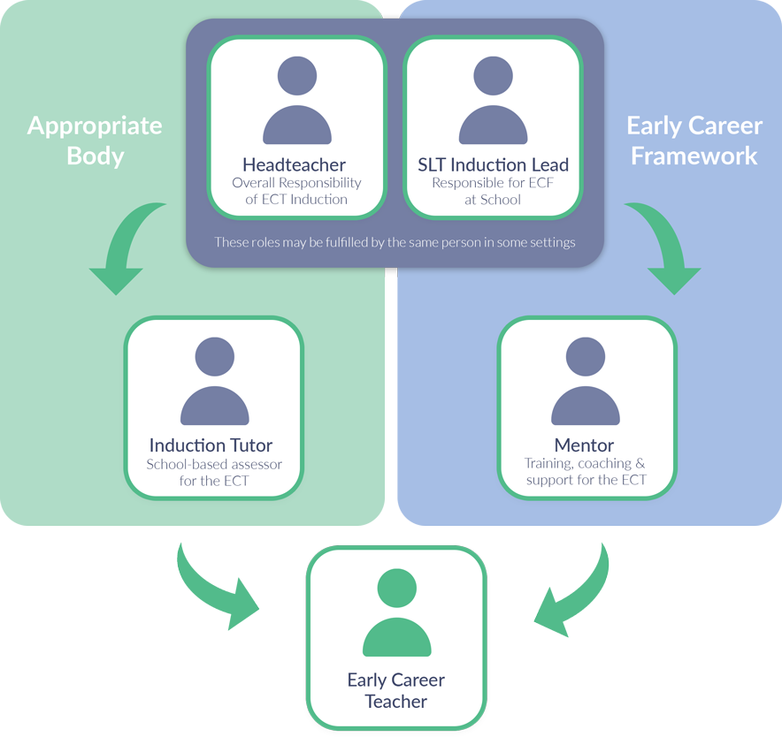

Fidelity Check – Core Induction Programme (CIP)

Each school offering an ECF induction based on a Core Induction Programme (CIP) is subject to a series of fidelity checks by an appropriate body. This form is to be used by schools to evidence how they have used a Core Induction Programme to deliver training and mentor sessions. Additional guidance on using this form can be found in chapter 4 of the Appropriate Bodies Guidance: Induction and the Early Career Framework.

The ECF outlines the support ECTs should receive at the start of their teaching career. It consolidates best available evidence and research in five key areas: behavior management, pedagogy, curriculum, assessment and professional behaviours, stating what teachers should learn and how to implement that knowledge. Using the framework, teachers will have the opportunity to engage in the evidence underpinning the framework and apply this to their teaching. This will provide firm foundations to develop their teaching practice, and ultimately accelerate pupil outcomes.

Building on the ECF, an ECF-based induction is an approach that supports an ECT to understand and apply the knowledge and skills set out in the ECF’s evidence statements (‘learn that…’) and practice statements (‘learn how to…’). ECF-based training should be embedded as a central aspect of induction; it is not an additional training programme nor is it an assessment framework. The training programme should also be accompanied by support and guidance from mentors and induction tutors.

Fidelity Check Stage One
- The member of staff responsible for planning the two-year ECF induction should complete this form
- This form should be signed off by the headteacher prior to the start of induction and sent to the appropriate body for verification (fidelity to the ECF)

Fidelity Check Stage Two
- The appropriate body will check implementation of the school’s plans prior to the completion of year one

Fidelity Check Stage Three
- The appropriate body will check actual delivery of the planned ECF-based induction prior to the final assessment point

Core Induction Programme – School Plans

This form should not be used to describe every session delivered over the entire induction period but should give the appropriate body a clear understanding of how Core Induction Programme materials will be used, including the sequencing of sessions.
Staff planning induction are expected to have good knowledge and understanding of the CIP materials available from their chosen CIP provider and pay particular attention to the planned sequence of sessions. They should refer to individual provider’s handbooks for further details on how their CIP programme is designed to be delivered.

Which provider’s Core Induction Programme has your school selected?
Information on the four options can be found online at: Early Career Framework – Core Induction Programme (education.gov.uk)

Please indicate your selection:

☐ Ambition Institute
☐ Education Development Trust
☐ Teach First
☐ UCL Early Career Consortium

1. With reference to the provider’s Core Induction Programme material, outline how the ECT training sessions will be delivered. Schools might wish to set out a termly breakdown of how the training sessions will be scheduled/sequenced over the course of the induction period.

School to complete this section prior to the induction period.
[Suggested word count: 250]

2. At the review points agreed with the appropriate body, outline, including dates where appropriate, where delivery of ECT training sessions has diverged from the planned sequence. Explain what mitigations are in place.

School to complete this section prior to the year one/two review meetings if appropriate.

3. With reference to the provider’s Core Induction Programme material, outline how the mentor sessions will be delivered. Schools might wish to set out a termly breakdown of how the training sessions will be scheduled/sequenced over the course of the induction period.

School to complete this section prior to the induction period.
[Suggested word count: 250]

4. At the review points agreed with the appropriate body, outline, including dates where appropriate, where delivery of mentor sessions has diverged from the planned sequence. Explain what mitigations are in place.

School to complete this section prior to the year one/two review meetings if appropriate.

5. With reference to the provider’s Core Induction Programme material, outline how the self-directed study will be delivered. Schools might wish to set out a termly breakdown of how the training sessions will be scheduled/sequenced over the course of the induction period.

School to complete this section prior to the induction period.
[Suggested word count: 250]

6. At the review points agreed with the appropriate body, outline, including dates where appropriate, where delivery of self-directed study has diverged from the planned sequence. Explain what mitigations are in place.

School to complete this section prior to the year one/two review meetings if appropriate.

Signature
By signing on this page, I confirm that the information provided on this form, to the best of my knowledge, is accurate, correct and complete.
Headteacher Signature

Date (DD/MM/YYYY)

GDPR statement on data collection: As documented in Statutory Guidance, ABs are responsible for the collection, retention and storage of data. ABs are responsible for submitting relevant data to the TRA via the DQT. Please visit www.tshubsfet.org.uk to read privacy notice.

Please return completed form to Gabby Janes (gjanes@sfet.org.uk)

