BUILDING BRILLIANT BEHAVIOUR MASTERCLASS SERIES
Behaviour, Learning and
Learning Behaviours-

Empower every individual and upskill your whole team to Challenge their Choices and Speak with One Voice
on your school or setting’s policy and practice in:
Building Brilliant Behaviour,
Limitless Learning and
Supporting Self-Regulation

‘Every interaction with a child is an opportunity to learn- for them and for us!’
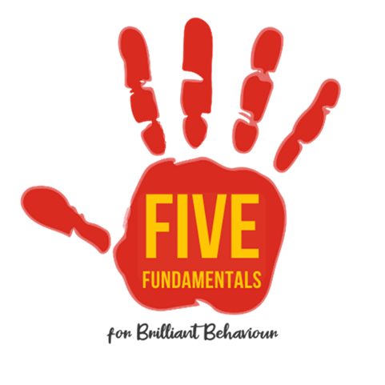

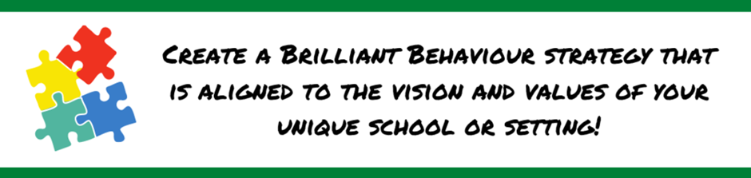

If you are in a position to inspire others or have responsibility for upskilling colleagues, this Masterclass Series for Brilliant Behaviour, Learning and Self-Regulation will inspire and empower you to embrace a unique and unified approach to managing behaviour. With all you need provided-you will leave feeling confident that your unique team are able to support their children and families - with a depth that makes the difference.
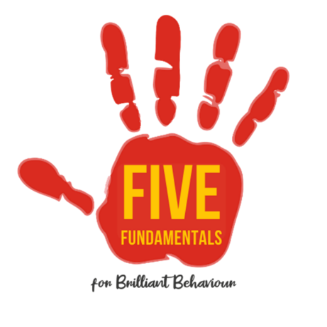

Tuesdays 3.30-5.30 1st March to 24th May 2022
Six live and interactive small group sessions with ongoing support and all the resources you need to train your team!

Children and educators have experienced some of the most unsettling times in education history
How we handle situations when behaviour becomes challenging is crucial- for the well-being of the child, their peers and of the adults involved
Having a unified approach that is perfectly matched to your school or setting is the key to happy, successful learners.

Whether your behaviour policy and strategies are
strong and well established
or
in need of an M.O.T.
there is so much to be taken into consideration to make sure they support your children and staff in the best possible way.

Inspired by years of experience supporting schools, early years, trainees and families,
Carefully crafted training proven to ‘leave a lasting legacy’.

Seemingly simple strategies with a ‘depth that makes the difference’

FIND OUT MORE? office@alimcclure.co.uk 07816 408181
This masterclass series is aimed at making your school or setting work more effectively, for our children, for our families and… for us!

The Brilliant Behaviour, Learning and Self-Regulation masterclass series has been designed to encourage you to reflect on your practice with a ‘depth that makes the difference’. It has been created so that what you learn can be applied in partnership with parents and practitioners to make tangible, long-lasting improvements for your team and families. And all this will have a positive impact on your children’s learning and their lives.
The Masterclass sessions will cover:
We are confident that this empowering and important series is worth considerably more than the £450 suggested investment, so if you are in a position to pay- Thank you for investing for the future.
Unfortunately for some, finances are an issue right now- if this applies to you we are always happy to be flexible so do get in touch and let us know how we can flex to meet your needs
office@alimcclure.co.uk 07816 4081
Relationships and resilience
Respectful responses
Self-regulation and emotional wellbeing
Supporting those who struggle with self-regulation
Rewards and resourcefulness
Rules, routines and relationships you can rely on
Reflective learners, responsive teachers
Why choose Ali McClure? 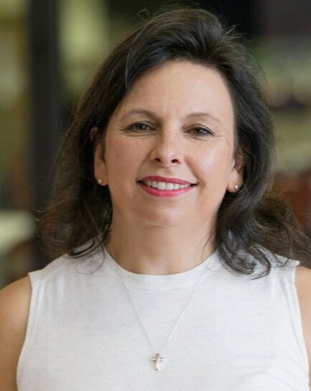

“Ali’s experience and sharp insight mean that she knows what she believes in, she knows why it works.”

Current & cutting-edge
Ali is on top of the game when it comes to current research and practice, working with highly respected leaders in education , early years and Ofsted. Her work in teacher training and supporting settings means she is regularly at the chalkface, knows the challenges you are facing, and also knows how to help you overcome them. Her success in raising standards and helping those children who have struggled to break through barriers to learning makes her work realistic and relevant. Ali’s work is proven to help practitioners balance the demands of the curriculum and the needs of each unique learner while still cherishing childhood.

