Speed Bounce
Children work individually to complete as many speed bounces as possible in the time. Child 1 goes first, child 2 counts – record score then swap.
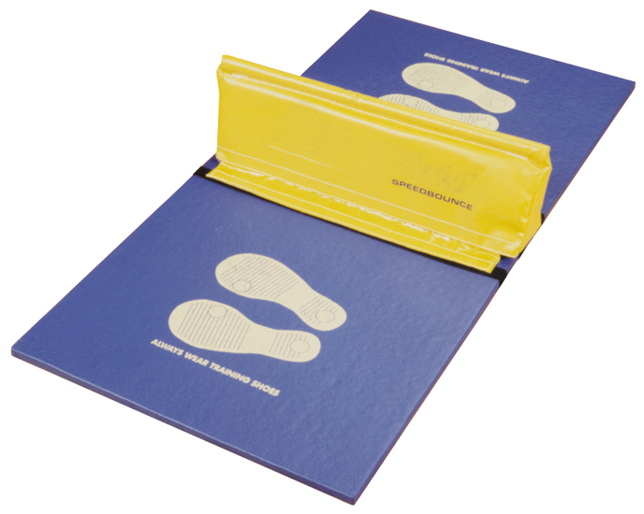

Step Ups
Children work individually to complete as many ‘Step Ups’ as possible in the time. To count the pupil must place one foot on the bench then step their second foot up before removing their first foot and following with their second foot (right foot up, left foot up, right foot down, left foot down = 1) Child 1 goes first, child 2 counts – record scores then swap.
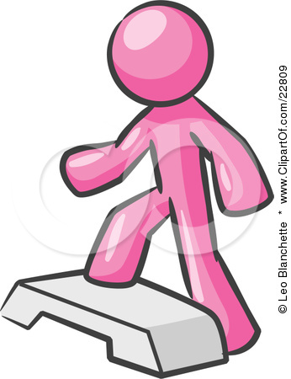

Ball Catch
Children work together to complete as many catches as possible in the time. If they drop the ball say on catch 12, they continue counting from 12 when they start again. Both pupils collaborate on this activity and therefore get 2 goes – record only their best score on their score sheets. They will both record the same score for this activity.
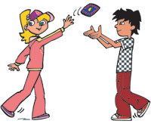

Skipping
Children work individually to complete as many skips as possible in the time. Child 1 goes first, child 2 counts – record scores then swap places.
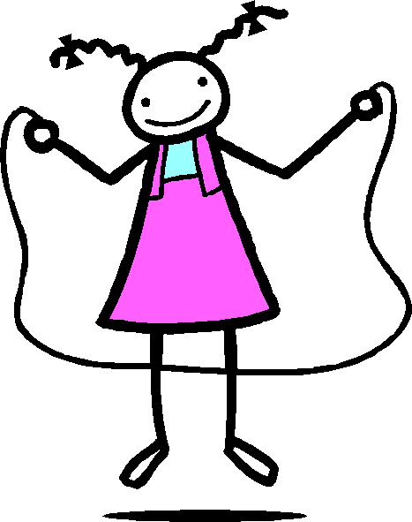

Star Jumps
Children work individually to complete as many ‘Star Jumps’ as possible in the time. Child 1 goes followed by child 2.
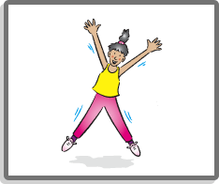

Throwing 4 Accuracy
Children work individually to throw as many beanbags into the target as possible in the time. The children only have 3 beanbags each so must work hard to retrieve the beanbags as fast as they can. Child 1 goes first, child 2 counts – record scores then swap.
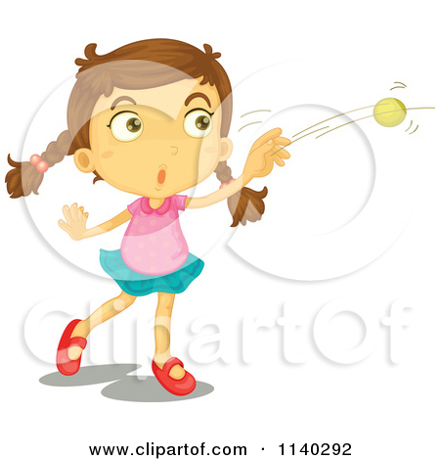

Sit Ups
Children work individually to complete as many ‘Sit Ups’ as possible in the time. Child 1 goes first, child 2 holds child 1’s legs/feet – record scores then swap. Encourage good quality activity – get a child to demonstrate this to the rest of the class.
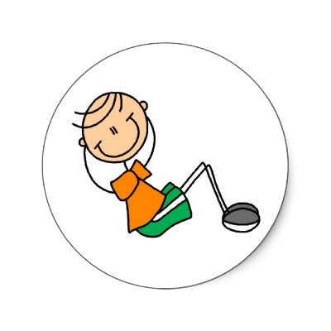

Shuttle Runs
Children run from the starting point at one cone in a clockwise (or anticlockwise) direction (please agree this before they start) to the other cone. Child 1 runs, child 2 counts and records their score then switch. NB if 2 pairs of pupils are completing this activity at the same time ensure 1 runner starts from each cone, so that they won’t bump into each other or fight to get to the first cone.
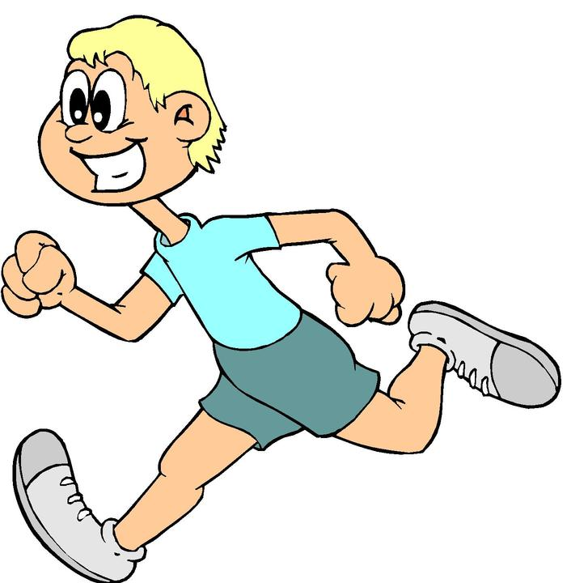

Spotty Dog
Children work individually to complete as many Spotty Dogs as possible in the time. Children start with their right foot and left arm forward – as if about to start a running race. Alternate your legs forwards and backwards. This is running on the spot essentially, but great for co-ordination!
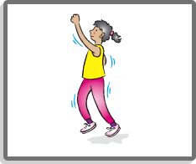

Squats
With backs against the wall, slide down so that the legs are bent and the knees are bent at 90º.
Adaptation: squat without the wall, make sure there is a straight line from ankle to knee and that bottom goes out behind the feet, back straight.
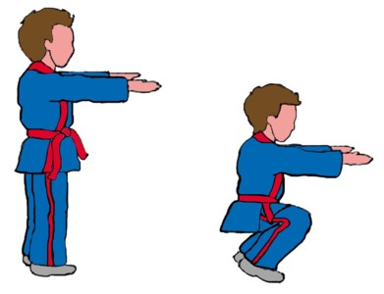
Beanbag Hold
Arms are parallel to the floor and they have to hold the beanbags up for the whole time.
Adaption: This exercise can be made more difficult by asking the children to slowly rotate their arms!
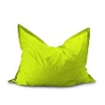

Ball head, shoulder, knees and toes.
Children start with ball held above their head, they then must bring it down to shoulder height, then down to knees and finally to toes before reversing the process. Children need to be shown the correct way of bending down. Child 1 goes first, child 2 counts and then swap.
Adaption – Use a tennis ball rather than a football


