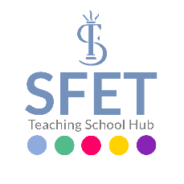

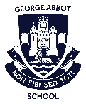
ECT Induction Overview - Appropriate Body

Early Career Teacher (ECT) and Induction Tutor training sessions and assessment points
Primary & Secondary Induction Service provided by South Farnham School in partnership with George Abbot School (with support from ECF regional delivery partners)

Year one |  |  |  |  |  |  | Year two
Term 1 |  | Term 2 |  | Term 3 |  |  | Term 4 |  | Term 5 |  | Term 6
ECT & Induction Tutor  Training | Progress Review |  | Progress Review | Induction Tutor  Assessment & evidence training | Assessment point one |  |  | Progress Review |  | Progress Review | Induction Tutor Assessment & evidence training | Assessment point two


Early Career Framework training & support underpins this assessment service over two years

